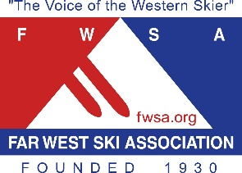

**88th ANNUAL FAR WEST SKI ASSOCIATION CONVENTION**

#### Marriott Mission Valley, San Diego

#### San Diego, California – October 7-10, 2021

***“Sail into San Diego”***

*“Fun in the O.C. Sun”*

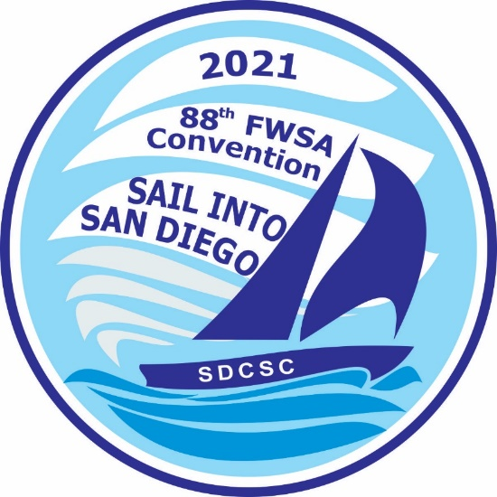

**SPONSORSHIP OPPORTUNITIES**

*As a non-profit organization, the* ***FWSA*** *programs and services are funded through sponsorship support. Active programs are conducted in ski safety, ski history, public lands development, industry relations, athletic development, recreational racing, travel, communications, council development, education, community support and awards****. ALL SPONSORSHIPS can be shared between partners, to allow for smaller businesses to support FWSA, while giving more sponsor exposure****. Following are sponsorship opportunities for the* ***88th*** *Annual* ***FWSA*** *Convention in San Diego, California:*

**DELEGATE TOTE BAGS – *SPONSORED BY ZERMATT UTAH ADVENTURE RESORT & SPA, DEER VALLEY RESORT & HEBER VALLEY TOURISM***

Company name and logo printed in color on tote bags, distributed to all Convention attendees, carried with Convention materials throughout the weekend and used by delegates post-Convention.

**DELEGATE NECK WALLETS – *SPONSORED BY SKI DAZZLE***

Specially-ordered neck wallets, with sponsor’s name and logo. Used by all Convention Delegates.

**DELEGATE BOOK PRINTING – *$1,000***

Company name and logo printed in color on back cover page of Convention Delegate Book.

**EVENING ON CORONADO (Wednesday**  - **$850**

Sponsor hosts the event. Sponsor receives one complimentary registration for the event

**TASTE OF SAN DIEGO PUB CRAWL (Thursday)** - ***SPONSORED BY STEAMBOAT SKI & RESORT CORPORATION***

Sponsor hosts the annual event. Sponsor receives one complimentary registration for the event.

**HORNBLOWER HARBOR CRUISE (Thursday**) – ***$1,000***

Sponsor hosts the event. Sponsor receives one complimentary registration for the event.

**CORONADO BIKE TOUR** – ***SPONSORED BY POWDER MOUNTAIN***

Sponsor hosts the event. Sponsor receives one complimentary registration for the event.

**MICHAEL GERMAN MEMORIAL 14TH ANNNUAL GOLF TOURNAMENT (Friday) – *SPONSORED BY ASPEN & SNOWMASS TOURISM***

Sponsor hosts the 14th Annual Michael German Memorial Golf Tournament at Riverwalk Golf Club. Continental Breakfast and lunch provided. Sponsor receives one tournament entry fee and participation in the awards’ presentation.

**OLD TOWN TROLLEY TOUR** **– $1,000**

Sponsor hosts the event. Sponsor receives one complimentary registration for the event.

**AQUA ADVENTURE** - ***SPONSORED BY BRIAN HEAD RESORT***

Sponsor hosts the event. Sponsor receives one complimentary registration for the event.

**POOL PARTY (Friday) – *SPONSORED BY JACKSON HOLE MOUNTAIN RESORT***

Sponsor hosts the event. Outdoor activities hosted by Central Council of California.

**SILENT AUCTION – BEER SPONSOR (Friday - – *SPONSORED BY ALTERRA MOUNTAIN CONPANY***

Sponsor hosts beverage station at Friday Night’s 35th Annual Silent Auction.

**SILENT AUCTION – WINE SPONSOR (Friday) – *$1,250***

Sponsor hosts beverage station at 35th Annual Silent Auction.

**CONTINENTAL BREAKFAST (Saturday) – *SPONSORED BY MAMMOTH MOUNTAIN SKI AREA***

Sponsor hosts the Continental Breakfast, shows a brief video presentation, and participates in the opening session of the Convention.

**LUNCHEON (Saturday) – *SPONSORED BY CLUB MED***

Sponsor hosts Saturday Luncheon, welcomes delegates and shows a brief video presentation. Sponsor give-away placed on all tables (optional).

**LUNCHEON BEER SPONSOR (Saturday)** **-** ***$1,000***

Sponsor hosts Saturday lunch beverage. Sponsor give-away placed on all tables (optional).

**LUNCHEON WINE SPONSOR (Saturday)** **-** ***SPONSORED BY SKI.COM***

Sponsor hosts Saturday lunch beverage. Sponsor give-away placed on all tables (optional).

**KEYNOTE SPEAKER PRESENTATION (Saturday) -  *SPONSORED BY MT. BACHELOR & RIVERHOUSE ON THE DESCHUTES***

Sponsor hosts the Keynote speaker for multi-media presentation. Sponsor shows a brief video presentation and introduces speaker.

**BANQUET SPONSOR (Saturday**) **- *$1,500***

Sponsor hosts the Awards Banquet. Sponsor shows a brief video, and is seated at the head table. Sponsor give-away placed on all tables (optional).

**BAND SPONSOR** - **$1,000**

Sponsor hosts the Band. Sponsor is seated at the head table. Sponsor give-away placed on all tables (optional).

**BRUNCH (Sunday) – *$1,500***

Sponsor hosts the Brunch, welcomes delegates, and shows a brief video presentation. Sponsor give-away placed on all tables (optional).

***\*\*NOTE: ADDITIONAL SPONSORSHIPS ARE AVAILABLE FOR OPTIONAL ACTIVITIES. For additional information: Debbi Kor, VP of Marketing & Sponsorship, Far West Ski Association * 503.314.7078*** *\** ***fwsadebbi @comcast.net . ALL SPONSORS are given the opportunity to place give-aways in the Delegate Tote Bags.***